Joseph Ayo

Module 2.3 Assignment – CSD 310

Original Flowchart:

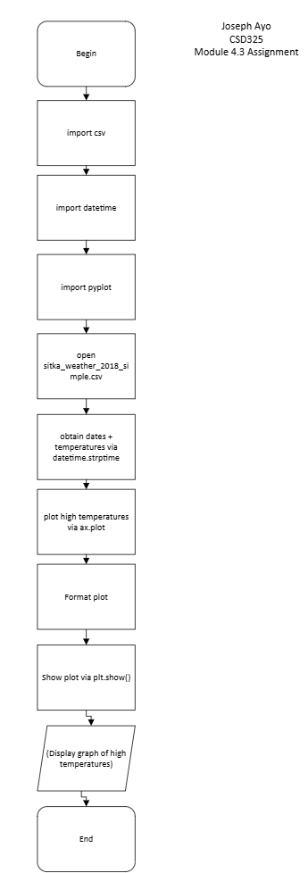

Second Flowchart:

